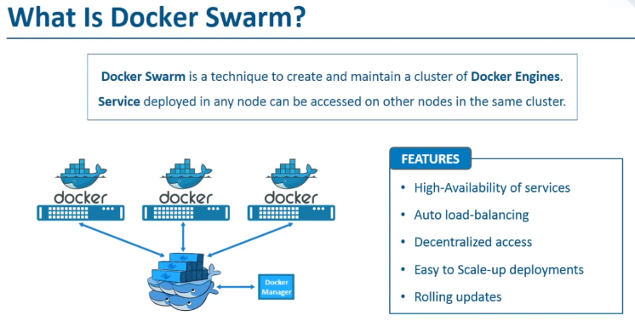
Lets create the above diagram and see all this features ‘practically’:

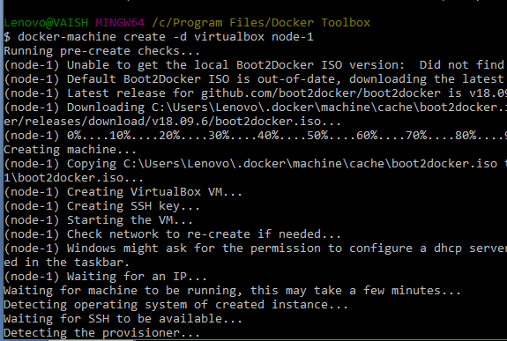
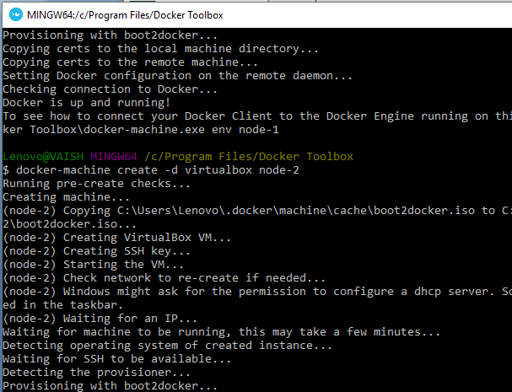

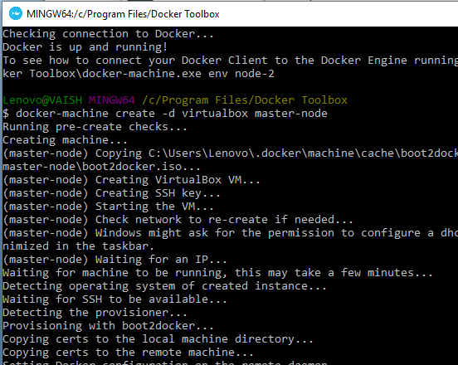
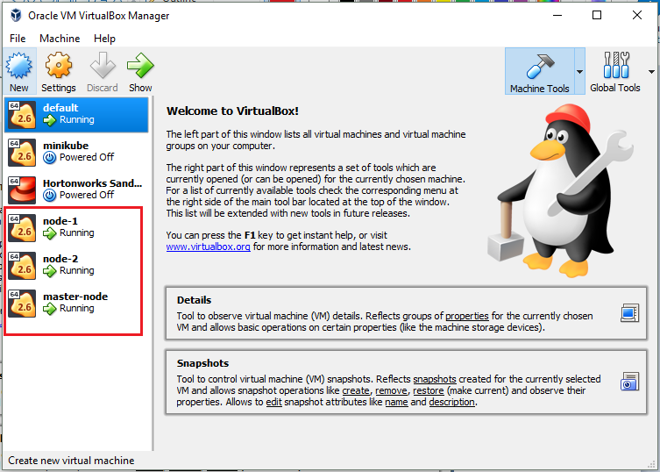
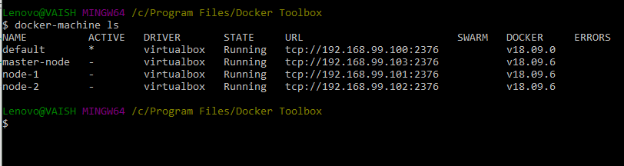
We can see all the nodes here. Right now these are simple nodes which are not connected with each other. No Master-Slave hierarchy is yet being followed.
The naming convention of master-node, node-1 and node-2 has been made so that respective responsibilities will be given to them in future.
Let’s switch to a node (names ad master-node)
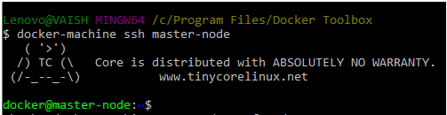
You can see the terminal prompt changed to docker@master-node. Here we will initialize docker swarm:
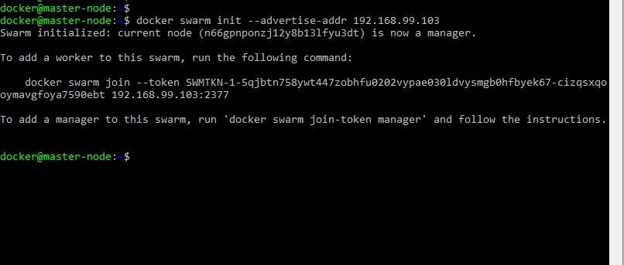
NOTE: Here, we used Master Node’s IP. And after initialization, we can read that this node (which was named as master-node) has actually become master. The intension behind nomenclature is fulfilled.
Now, it’s time to add the nodes in the swarm: Launch a new Docker Terminal and issue the below command to switch into a node (This time worker node):
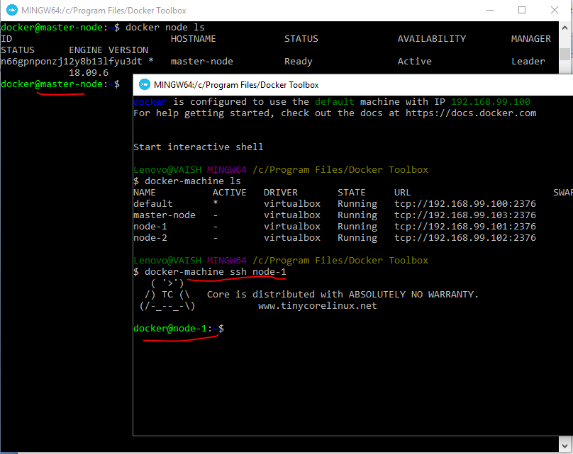
If you noticed in the previous figure, when we initialized the docker swarm from a node (named master) to make it the actual master, in the terminal the command with token was generated. Now to add node-1 in the swarm we will make use of the same.
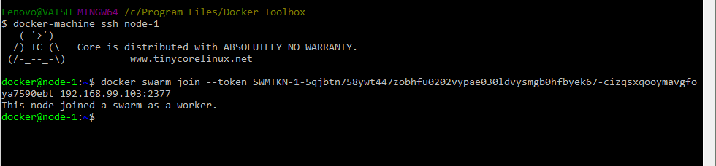

Similarly to add node-2 in the swarm, launch docker Terminal, ssh into node-1, issue the join command to register itself as a worker node in the swarm.

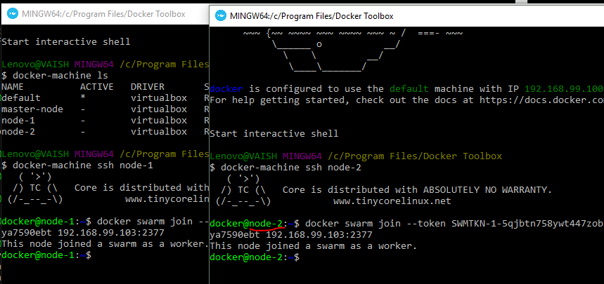

To check the Master –Slave Architecture:
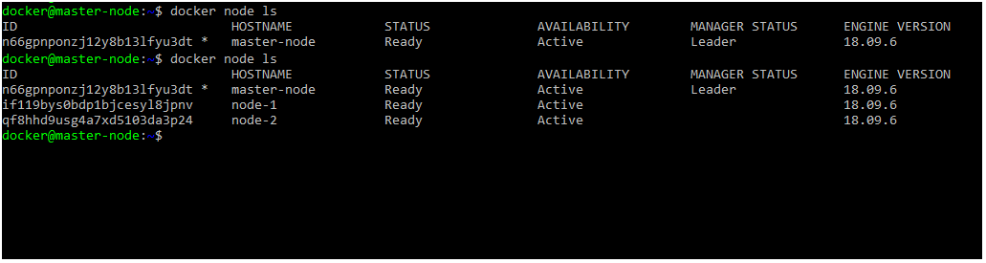
To Test:
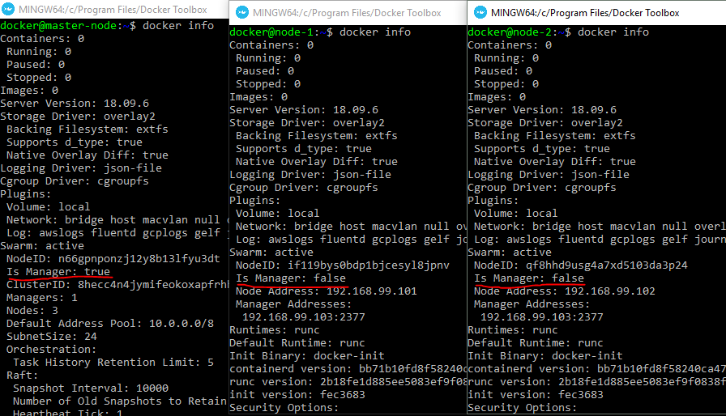

Now, we have our swarm up and running!!
Time for Application Deployment:
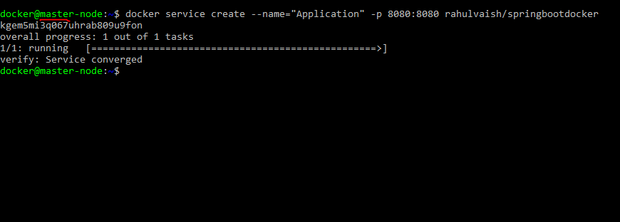
The app is UP and RUNNING. To test, use MASTER’s IP and 8080 as port.
To determine MASTER’s IP, launch a fresh Docker Terminal, and issue docker-machine ls, as below:
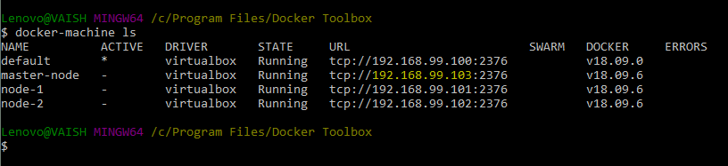
It’s the same IP as what we wrote during swarm initialization:
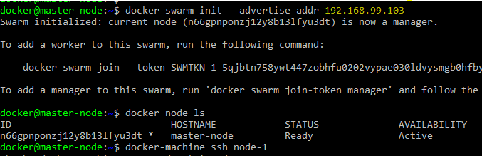
Using the IP, and port, we can see the Application is UP and RUNNING ☺
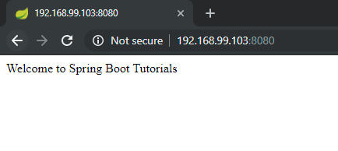
To test the service status:
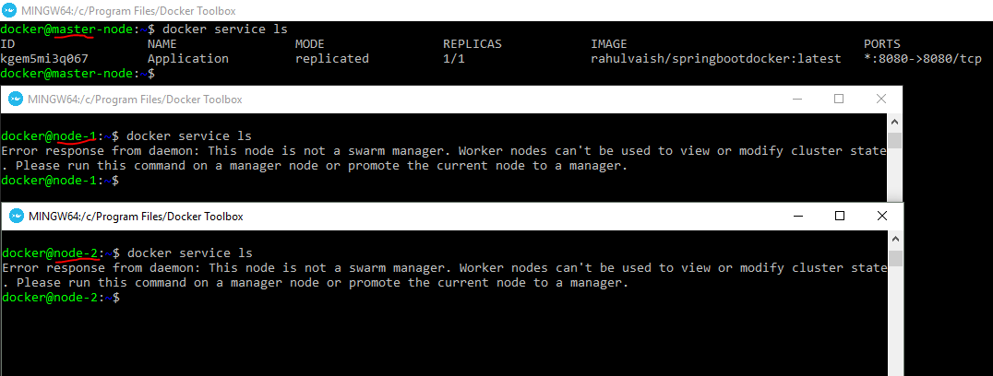
Executing , docker service ls and docker service ps , we come to know that they are supposed to execute on master node and not on worker nodes!

On executing docker ps, on master , node-1 and node-2, it was determined that the process is listed under Node-2.
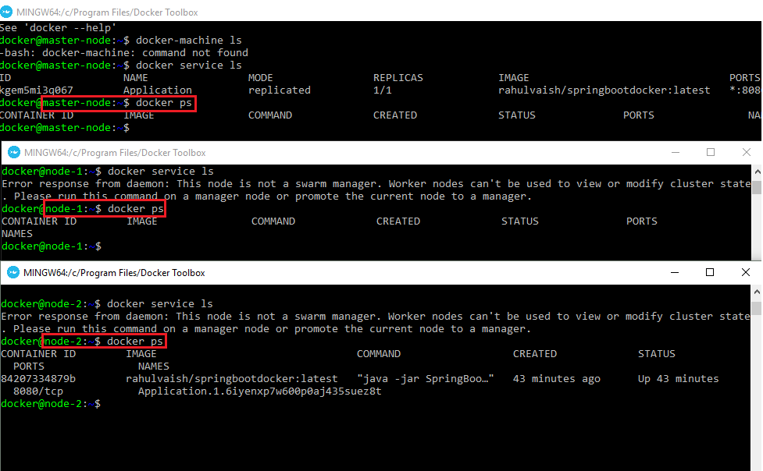
Now let’s see how to create number of instances for each node. To do the same, first pull down the running service, and post that re-create the new service with global mode.
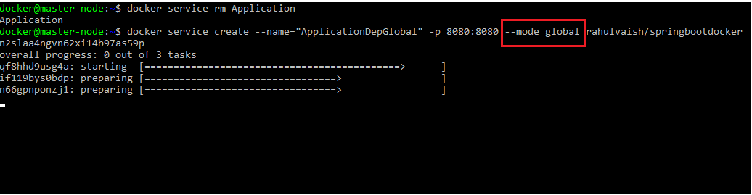
Now on docker ps on all three nodes
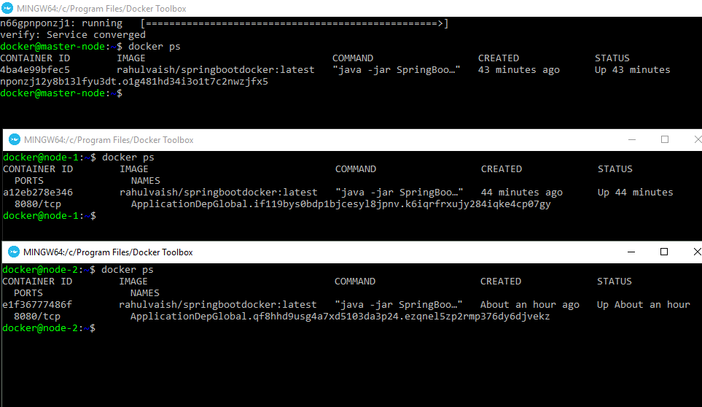
Therefore, we can see that instances of the application are running on all 3 nodes ☺
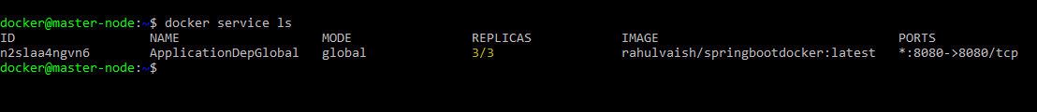
Again, we can see the number of replicas =3 . One Replica/Node.
HIGH AVALIBILITY
To test the availability, let’s shut down one node…
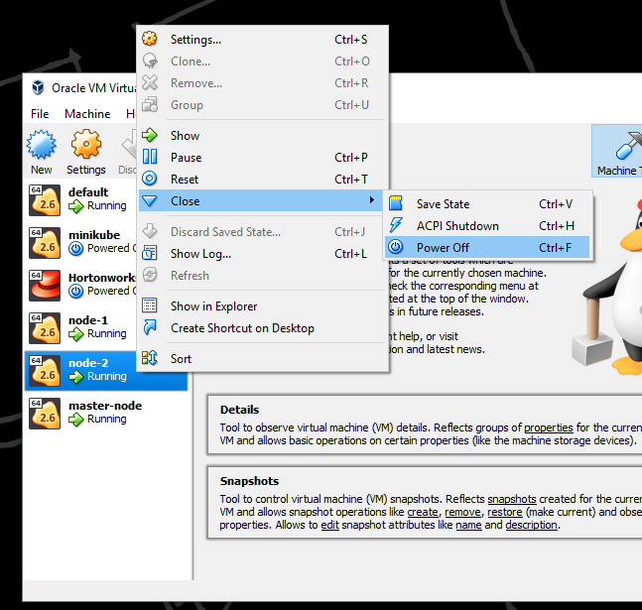
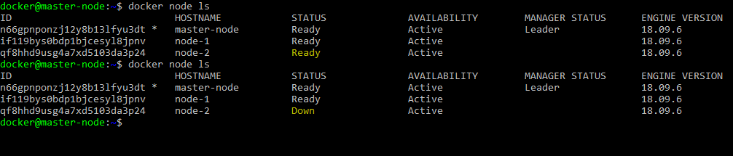
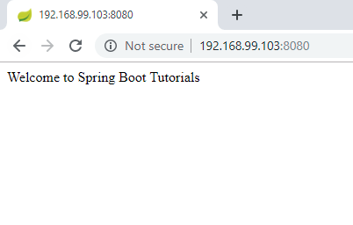
Even if one node goes down, the application is running ☺

Now, start the node (From Virtualbox)
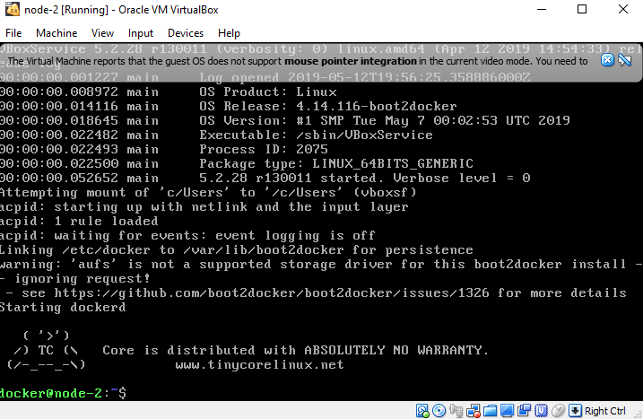
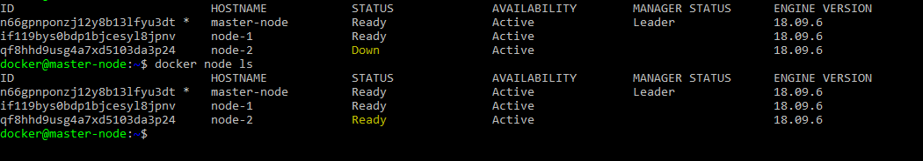
The earlier state is restored!!
Earlier we saw that we deployed the application on all three nodes, in case we want to make deployment on let say only 2 nodes, then:
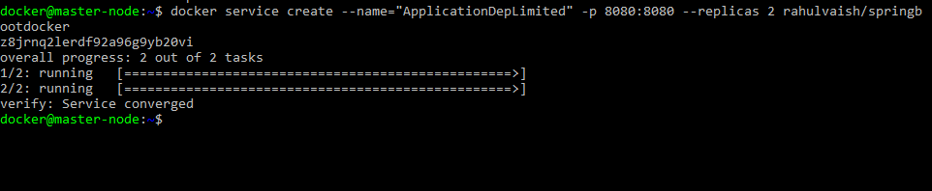
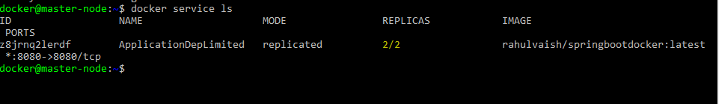
Now which are these two nodes?
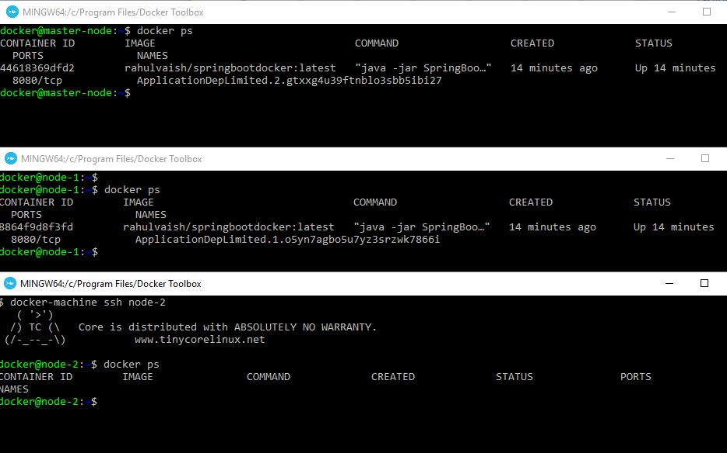
The service is UP and RUNNING on Node-1 and master.
Scaling up our application on Node-2….
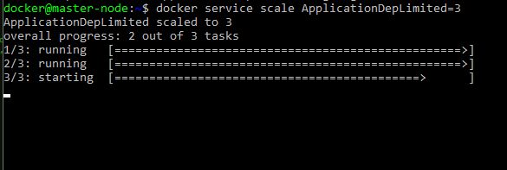
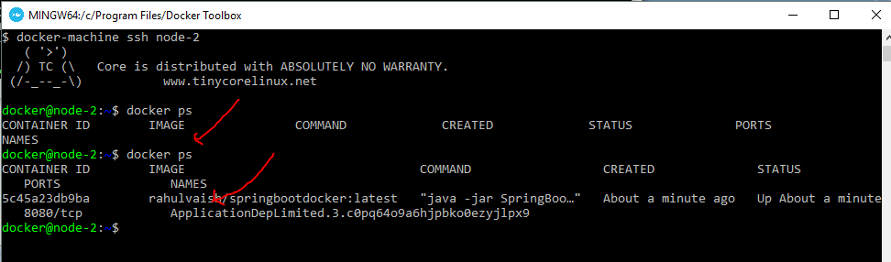
Before/After state of Node-2

Experimenting some Thoughts:
Q1. Deploy SpringBootDocker and SpringBootDocker –v2 on Docker Swarm.
The deployment of springbootdocker happened on node-1 and deployment of springbootdocker-v2 happened on node-1. Node-2 empty with no deployment made over there.
Q2. On 3 nodes (in total) if we replicate the Application on 10 nodes, what will happen?
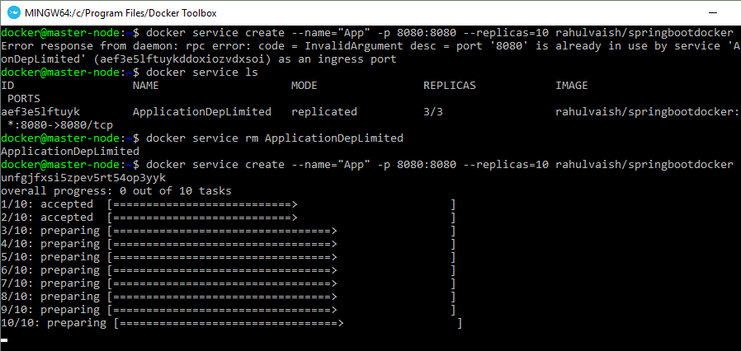
These 10 instances are divided into all 3 nodes:
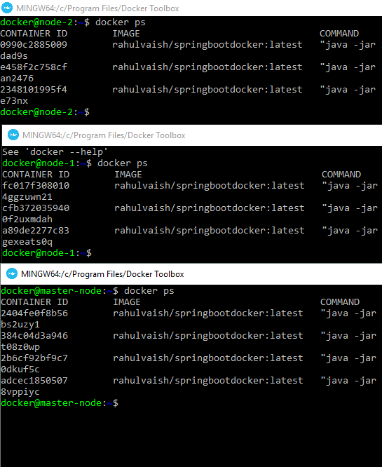
Q3. What if we switch on any node that does not exists?
Answer:
Lenovo@VAISH MINGW64 /c/Program Files/Docker Toolbox
$ docker-machine ssh node-10
Docker machine "node-10" does not exist. Use "docker-machine ls" to list machines. Use "docker-machine create" to add a new one.

Q4. How to make a node free from deployment?
Answer:
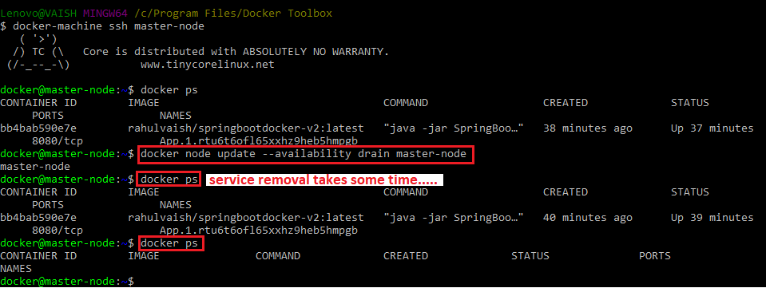
But as we have set the replication factor as 2, and we removed service from master node, therefore the replica is created on Node-2, which was then empty…
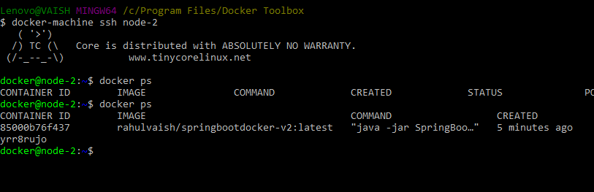
Now, as we have tagged that master won’t take any deployments, therefore, on re-trying a deployment ,the deployment goes in any other node (except master), here in our case its node-2.
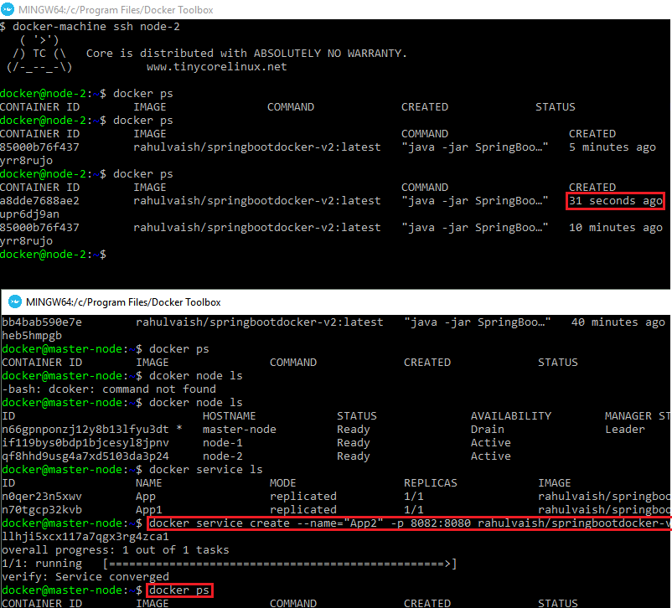

Docker vs Kubernetes:
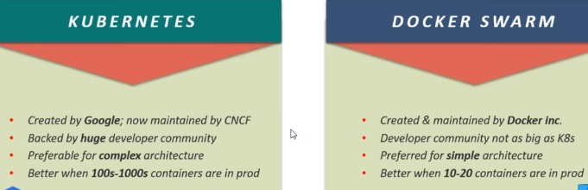
K: Setting up Kubernetes Cluster is complicated and time taking.
DS: Easy
K: GUI
DS: No GUI
K: Scalability is easy
DS: Scalability is easy and 5X Faster
K: Autoscaling
DS: Manual Scaling
K: Manual Load Balancing
DS: Auto Load Balancing

